**NETWORKING DOCUMENTATION FOR CENTOS**

**Brayan Rosario**

**CIS-245**

**LINUX ADMINISTRATION**

Document network setup. This should include locations of any files you've created or need to reference. You should include any programs you've installed or updated as well, with dates of when you've done those things. Include a short document including how you did any of the installs or updates. 

Write a script to dump network info (including ip, dns, open ports and anything else you think is useful) to the commandline and to a file.  Make sure the name of the file includes the date and the purpose.

Deliverables:

A document that is your current network setup, including notes of what is installed, the last time it was updated and any changes you've made to the defaults.

A well commented and well tested script, and a sample run of your script on each server.  Include any instructions needed for running the script.  Such as, does it need to be run in a special folder? does it save the textfile to a special place (it should) and where that might be? Which commands you've chosen to put in the script and why.

**The IP address : the IP address with the most common stand for Internet Protocol Address and all of the devices that is connected to a network possess one. It can be comparable with phone numbers.**

**To run the IP on your server will give you a list of all the Broadcast and the Loopback following of a IP address and mac address as well.**

**IP ADDRESS**

**The DNS**

**The DNS stand for Domain Name Server is an internet service that maps IP addresses and fully qualified domain names computer that run DNS are called name servers.**

**To run it**

**Cat /etc/resolv.conf**

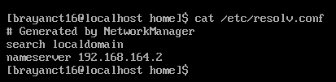

**The ss**

**SS – is a program named netstat that can be use to do some replacement and get information about the possible open ports about the networks.**

**To run the command**

**Ss -tule**

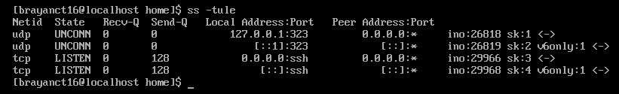

**The Nslookup: is a program to query Internet domain name server Interactive mode allows the user to query name server for information about various hosts and domains or to print a list of host in a domain.**

**To run it on your server:**

**Nslookup google.com**

